**Project Design Phase-I**

**Solution Architecture**

|  |  |
| --- | --- |
| Date | 06 May 2023 |
| Team ID | NM2023TMID21570 |
| Project Name | Empowering the Future: A literacy Rate Analysis for a Better Tomorrow |
| Maximum Marks | 4 Marks |

**Solution Architecture:**

**Our solution**:

Statistical analysis tools, data visualization software, and programming

languages

**Structure:**

* **Define the research question:** 
  + - Start by defining the research question that the literacy rate analysis project will address
* **Gather data:**
  + - Collecting data on literacy rates, as well as any other relevant data that may help to answer the research question.
* **Clean and process data:**
  + - Data will need to clean and process it to prepare it for analysis. This may involve removing duplicates and outliers, dealing with missing data
* **Analyze the data:**
  + - Use statistical analysis tools to analyze the data and explore relationships between different variables.
* **Interpretation and Visualization:**
  + - The results of the model are interpreted and visualized to provide insights into the features.
    - **Communicate the findings:**
* This may involve writing a report, creating a presentation, or sharing results through other channels.

**Characteristics:**

This may draw on multiple disciplines, such as education, economics, sociology, and statistics, to provide a comprehensive understanding of literacy rates and their determinants.

This will rely heavily on data to identify patterns and relationships between different variables. The analysis may involve collecting, cleaning, and processing large amounts of data from various sources.

**Behaviour:**

It evaluate the effectiveness of different education policies and identify which policies have the greatest impact on literacy rates. This can inform future policy decisions and help to improve education systems. It can demonstrate the economic and social benefits of investing in education, which can encourage policymakers to allocate more resources to education and literacy programs.

**Features:**

* Multidisciplinary approach
* Data-driven
* Contextual
* Collaborative
* Evidence-based
* Policy-relevant

**Development Phases:**

* Define the research question
* Review the literature
* Collect data
* Clean and prepare the data
* Analyze the data
* Communicate the results

**Solution Requirements:**

* Data collection and management tools
* Statistical analysis software
* Visualization tools
* Collaborative tools
* policy analysis frameworks
* Evaluation tools

**Specifications:**

* Research question
* Data sources:
* Variables
* Sampling
* Data analysis
* Visualization
* policy recommendations

**Solution Architecture Diagram:**

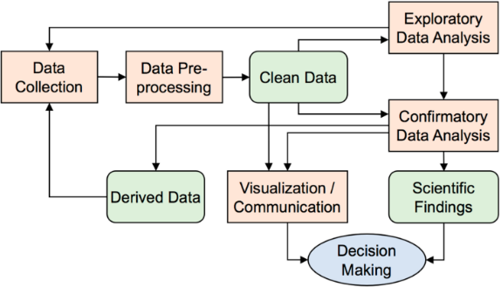

*Figure 1: Architecture of Literacy rate analysis for a better future tomorrow*